To Access OneNote from a Mobile Device

- Download the free OneNote App from the App Store.
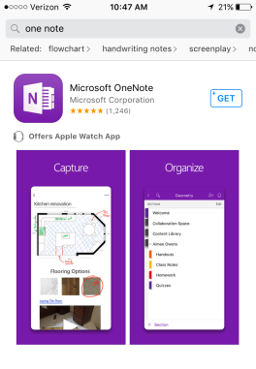
- Select “Sign In”. DO NOT select “Sign Up For Free”.
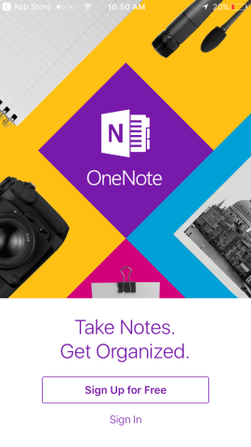
- Enter your UCS Email. Username@stu.uticak12.org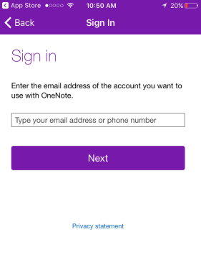
- Enter your UCS username or email address and password.
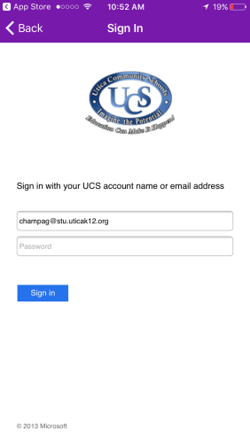

- Choose which notebooks you want to see on your screen. You will be able to access your Algebra I Notebook now.
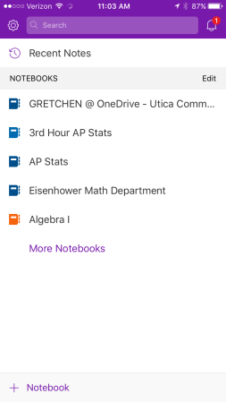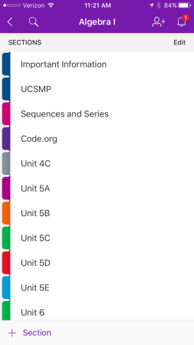

- Sometimes you will need sign back into your OneNote account. If you notice a warning symbol next to your notebooks or at the top of your open notebook, you will have to re-sign in.
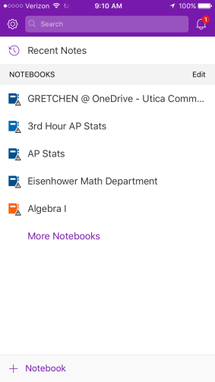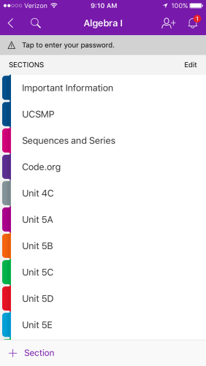

- Click on “Tap to enter your password.” Enter password. Then reenter email.
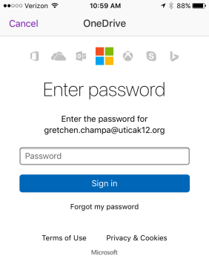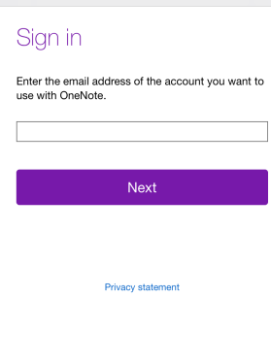
- Then you will have to choose “Work or school account. This takes you back to sign in screen to enter password.
