To Access OneNote from a Laptop or Desktop
- Go to mail.ucs.org
- Enter your UCS username and password.
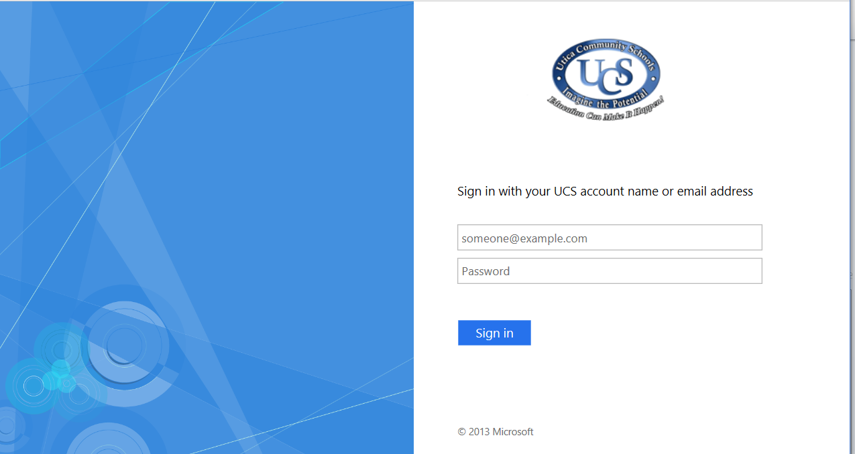

- This will direct you to your ucs email. This is something that you will continue to be asked to do this year, so learn how to access your email.
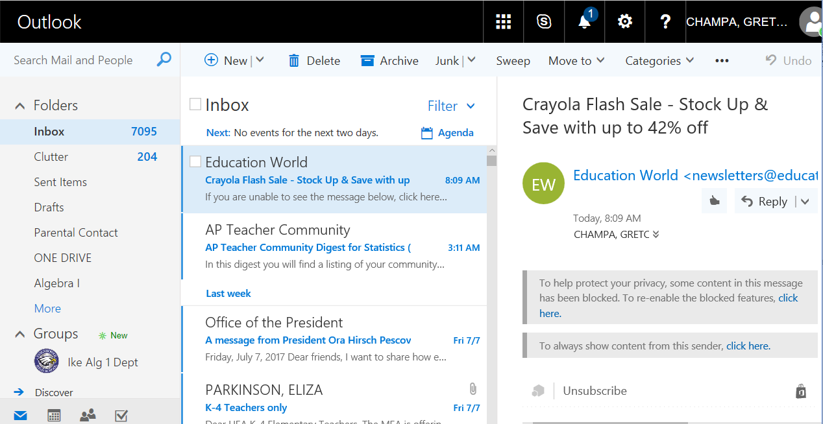

- Click on the waffle in the top bar of outlook.
- Choose the OneNote box. 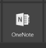
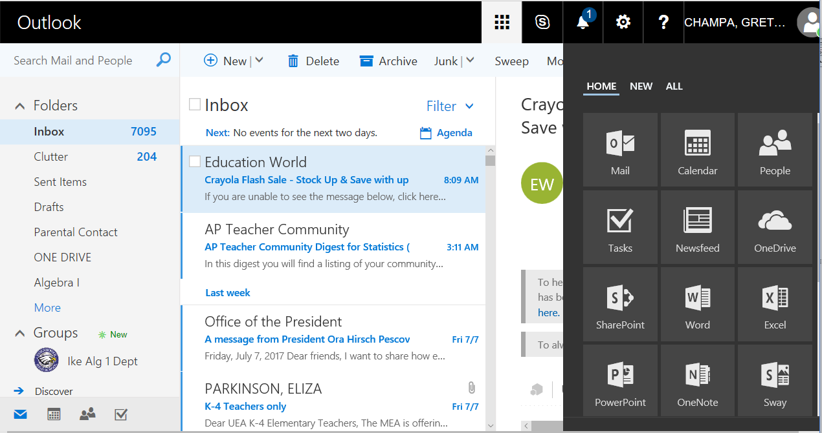

- Once you open OneNote, you will see a page with notebooks listed. This is the recently opened notebook page. You may not have anything listed here.
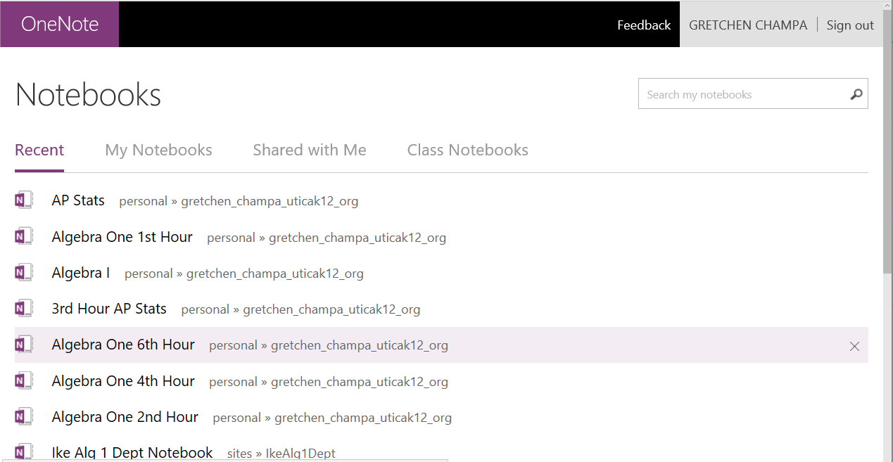

- Click on “Shared with Me”.

- You should see an Algebra I Notebook with your hour listed.
- Choose that notebook.
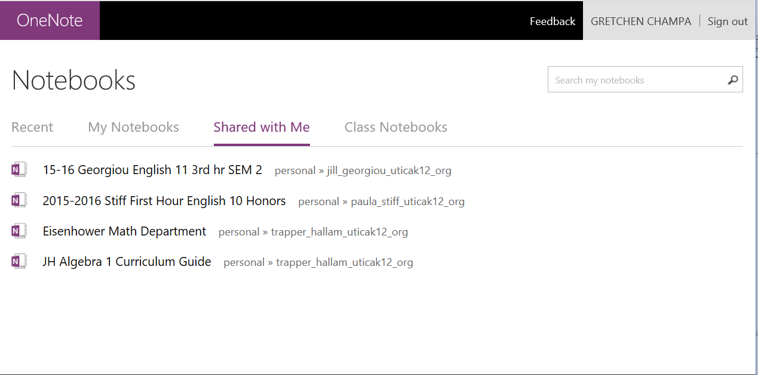
- You will be opened into the first tab of your Algebra I Notebook.
- Click on
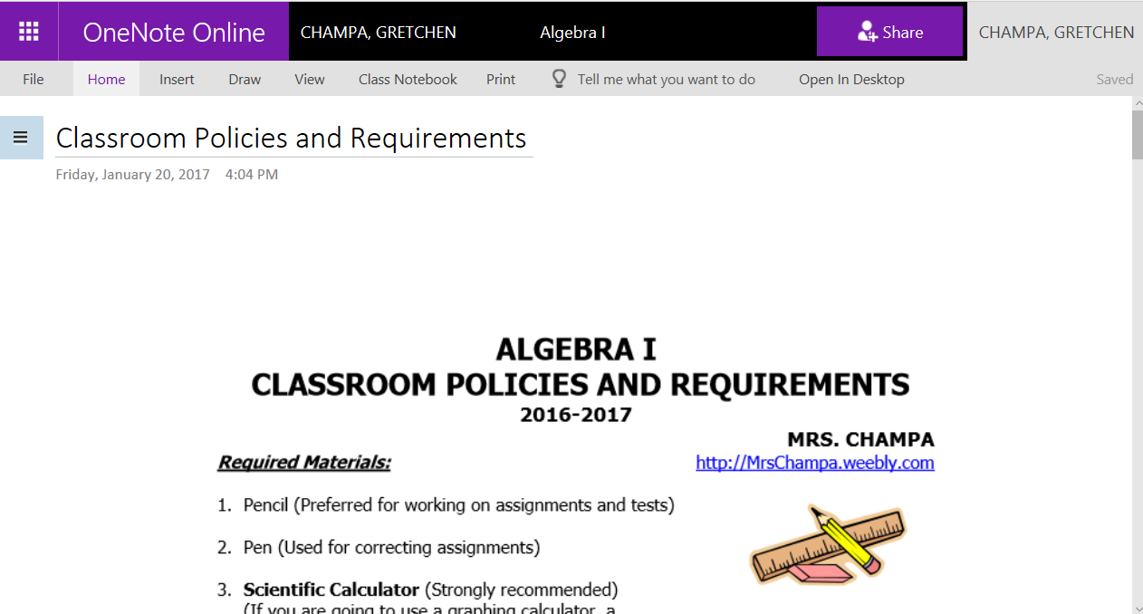

- You will see all of the tabs to your notebook listed to the left.
- Start to navigate around your notebook, getting used to how it works.
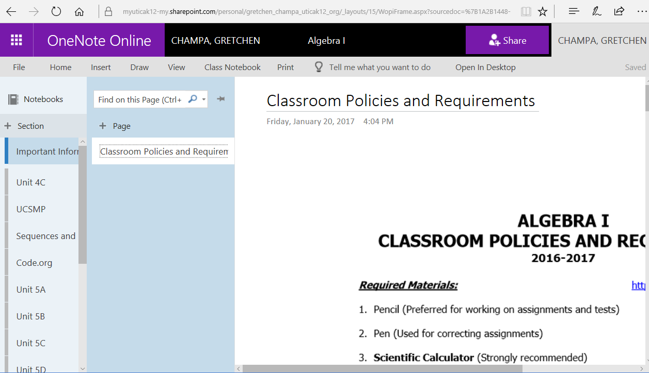
- This notebook can be accessed on a school or home computer. It can also be accessed by phone.

